CYBER SECURITY

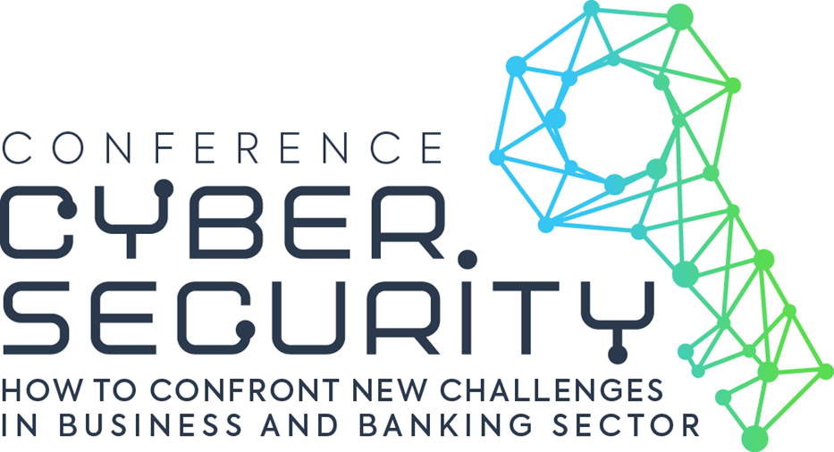

Powered by:

Under the auspices:

CYBER SECURITY conference
Agenda
How to confront new challenges in business and banking sector

09:00 – 09:30 Registration, refreshments and networking

09:30– 09:40 Conference opening
Nenad Popović, Minister of innovations and technological development, Government of the Republic of Serbia

09.40- 09.45 Welcome
Sergio Monti, Deputy head of Mission, Embassy of Italy in Belgrade

09:45 – 09: 50 Chair’s morning introduction
Erich Cossutta, President of Confindustria Serbia

09:50 – 10:30 Cyber security in banking sector - Security of information – vulnerabilities and hardening, defense tools
Moderator: Vladimir Petrović, Unicom Telecom
- Aleksandar Stanojević, CISSP, Banca Intesa
- Siniša Pajević, Security Unit- GBS Division, UniCredit bank
- Jasna Fumagalli, Head of Compliance, Security and Risk Management, Mercury Processing
- Dejan Simić, Bassilichi CEE & ArsBlue
- Miloš Pešič, Managing director-CEE & Adriatic, Ominitechit

10:30 – 11:15 Challenges in cyber security in Telecommunications sector
Moderator: Arpad Toth, Country Manager, Kaspersky Lab
- Vladimir Lučić, CMO, Telekom Srbija
- Slaviša Karanfilović, Information security manager, Telenor Serbia
- Marko Jovic, Head of General Affairs, VIP Mobile
- Sergej Petković, COO, Orion Telecom

11:15 – 11:30 Refreshments and networking break
Speak to counterparts from across the sector and pick up tips on responding to policy and best practice developments

11:30 – 12:15 Cyber threats : awareness and partnership for safety
Moderator: Peter Thompson, CEO, GCOMM
- Andrea Orizio, Head of Mission, OSCE mission to Serbia
- Dragana Ilić, E-Government Alliance, Co-ordinator, Naled
- Nataša Sekulić, Country Leader SMMA, IBM
- Dušan Rakić, Marketing Director Serbia, TeleGroup d.o.o.
- Vladica Tintor, director, RATEL
- Slobodan Nedeljković, Assistant Minister, Ministry of Interior of the Republic of Serbia
- Asseco, representative

12:15 – 13:15 New ways of keeping your data safe
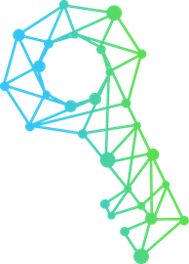
- Reduxio & NES Communications hardware/software concepts – separating data from metadata – process of making 1 second granularity in your backup data
- Kaspersky Laboratory – how to confront new challenges in changing IT environment – perspectives and challenges

13:15 – 14:00 Expert’s lead on cyber security:
Zvi Fischler, Chairman of the advisory board, ULTRA

14:00 – 14:15 Closing remarks – end of conference

